KINDERGARTEN
Lewis County Central Elementary

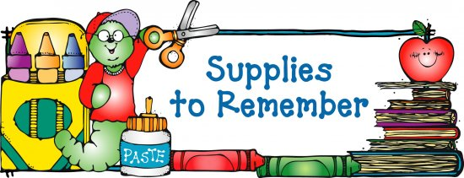
- 4 – 24 count packages of CRAYOLA crayons
- 1 box washable markers
- 12 glue sticks with purple tint
- 2 packages #2 yellow pencils
- 1 pair of primary scissors
- 3 boxes of tissues
- 1 package of 2 pink erasers
- 1 package of pencil cap erasers
- 2 boxes of Band-Aids
- Pencil box
Boys should bring: Girls should bring:
- Quart size Ziploc bags 1. Baby Wipes
- Gallons size Ziploc bags 2. Small paper plates
- Small plastic cups 3. Paper Towels
- Napkins 4. Sandwich size Ziploc bags
- Package of highlighters 5. Spoons
- Mr. Clean Magic Eraser 6. Package of dry erase markers

*****Each student should bring a backpack (no wheels) to school every day.*****

