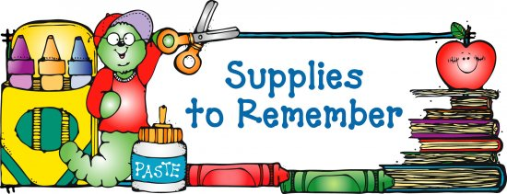

A Backpack of your choice (without wheels)

* 2 composition notebooks (black and white speckled)
*6-24 count box of Crayola crayons
*1 pack of Crayola markers
*1 pack Crayola colored pencils
*4 pack of pink pearl erasers
*3 boxes of Kleenex
*2 pack of glue sticks (6 pack)
*1 pair of Fiskar scissors
* 1 Picture folder of their choice for homework.
* 2 boxes of 24 classic #2 U.S.A Gold or Ticonderoga pencils
* 3-4 fine point dry erase markers (any color)
* 1 pack highlighters
* 1 tub of Clorox wipes
* Small flashlight
* Personal earbuds/headphones
* PENCIL BOX

Girls should bring Boys should bring
* hand sanitizer *Mr. Clean magic erasers
* baby wipes *1 packs zipper gallon size bags
* paper plates, forks and paper towels *cups, spoons, napkins
* Ziploc sandwich bags *Hand sanitizer
* 1 boxes Band-aids *1 boxes Band-aids

** No Individual pencil sharpeners**
** No mechanical pencils**

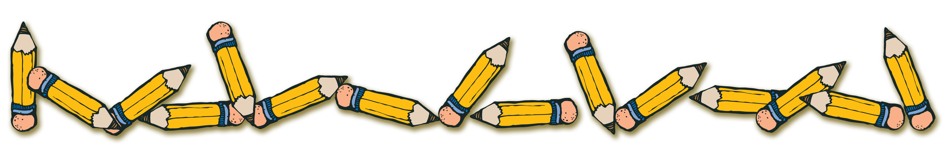
Thank you in advance!!!
Mrs. Gullett & Mrs. Yates & Mrs. Hunt

