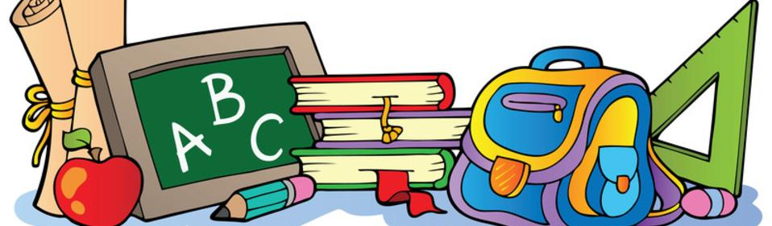
Lewis County Central Elementary 6th Grade Supply List

Must Have
4-Spiral Notebooks
5-2 pocket folders
Colored Pencils
Pencils
Erasers
Highlighters
Graph Paper
Loose Leaf Paper
Index Cards
Ear Buds

Nice to have
Trapper Keeper or Binder
Tissues
Paper Towels
Lysol Wipes
Band Aids

