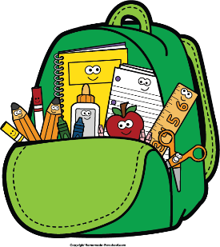
4th Grade Supply
A backpack of your choice (without wheels)

- 4-Black and White Composition Notebooks
- 1-Spiral Bound 1-Subject Notebook
- 4-Black Expo Markers
- 2- Pack Cap Erasers
- 2-24 count box crayons
- 2- pack colored pencils
- 4- Glue Sticks
- WOODEN PENCILS (Plain - NO PLASTIC WRAPPED) (NO MECHANICAL PENCILS)
- 2- bottles of liquid glue
- 1- 1 ½ WHITE BINDER - with clear cover to slide cover in (may need replaced at Christmas)
- 2- RED 2 Pocket folder (USED FOR HOMEWORK)
- 1 - pack loose leaf notebook paper
- 1 - pack sheet protectors
- 1 - pack dividing tabs
- 3 - pairs of EARBUDS
- 2 -Pencil pouch with 3 ring holes - NO PENCIL BOXES
- Ear Buds 2 pairs

What to have at home: Nice to have for classroom:
- Pencils * 3 - boxes tissues
- Pencil sharpener * 1 - box Ziploc sandwich bags
- Lined paper * 1 - box Ziploc gallon size bags
* 2 - rolls paper towels
* Disinfect Wipes

**All electronics are to be stored in the teacher’s desk UNTIL THE END OF THE DAY! If students are caught using devices, they will be taken and you can pick them up from Ms. Kidwell.

