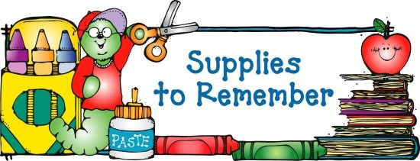

A Backpack of your choice (without wheels)

*2 composition notebooks (black and white speckled)
*6-24 count box of Crayola crayons
*1 pack of Crayola markers
*1 pack Crayola colored pencils
*4 pack of pink pearl erasers
*3 boxes of Kleenex
*2 pack of glue sticks (6 pack)
*1 bottle Elmer’s Glue
*1 pair of Fiskar scissors
*1 pencil box (Plastic box must be big enough to hold all supplies)
*2-2 pocket folders with prongs
* 1 Picture folder of their choice for homework.
*1 box of 24 classic #2 U.S.A Gold or Ticonderoga pencils
*3-4 fine point dry erase markers (any color)
*Mini flashlight (will get back at end of year)
* Over the ear headphones (will get back at end of year)

Wish List (These are supplies we use every day. Any donation of these supplies would be appreciated.)
*2 tubs of Clorox wipes
*baby wipes
*Mr. Clean magic erasers
*2 packs zipper gallon and sandwich bags
*cups, forks, spoons, paper plates, paper towels and napkins
* 2 boxes Band-Aids
*Hand Sanitizer

** No Individual pencil sharpeners**
** No mechanical pencils**

